KCG COLLEGE OF TECHNOLOGY
Engineering Chemistry II-CY3151
UNIT I-Water Technology
Part A and Part B Questions and answerrs
1. What are scale and sludge in boilers ? (or) Define scales and sludge.
Sludge: It is a slimy, loose and non-adhesive suspended mass formed in cold portion of boilers. It is formed due to presence of MgCO₃, MgCl₂, MgSO₄ or CaCl₂ in boiler water.
Scale: It is a hard, adherent deposit formed on the inner walls of boilers. It is formed due to CaCO₃, CaSO₄, Mg(OH)₂, SiO₂ or iron salts in boiler water.

2. Name some chemicals that contribute for sludge in boilers.
MgCO₃, MgCl₂, MgSO₄, CaCl₂.
3.Name the chemicals that contribute for scales in boilers.
Ca(HCO₃ )₂, CaSO₄, Mg(OH)₂, SiO₂ and iron salts.
4. What is the effect of sludge in boilers?
- Poor conductor of heat
- More fuel and more cost;
- Sludge deposits at bends and valve portions-hence choking and reduced steam flow;
- Sludge covered by strongly adhering CaSO₄ and Mg(OH)₂ is difficult to remove.
5. What is the effect of scales in boilers?
- Thermal insulators
- Decreases the efficiency of boiler
- Boiler explosion may occur.
6. How sludge in boilers is controlled? How sludge is removed?
(1) Use soft water
(2) Boiler blow down (i.e. constantly draining out the concentrated portion of water).
Sludge is removed by scrapping with wire brush.
7. What are the advantages of desalination process?
(i) Operation of domestic RO unit is simple;
(ii) Dissolved salts, organic substances and microorganisms are removed
(iii) Low TDS water is obtained
(iv) Even seawater and brine water can be purified.

8. What is priming and foaming in boilers? (or) Distinguish between priming and foaming.
The process of wet steam (water droplets in steam containing TDS and SS) formation is called Priming.
Foaming is formation of persistent or stable bubbles in boiler water. They do not break easily. They are formed due to oils, lubricants or alkali metal salts.

9. Why priming and foaming occur in boilers.(or)What is the reason for priming and foaming formationin boilers.
Priming: Priming is formed due to following factors –
(1) High TDS
(2) Rapid steam generation
(3) Sudden temperature change
(4) Change in steam velocity
(5) Poor boiler design
(6) Rise in water level
Foaming: Foaming is formed due to the reduction in surface tension due to the presence of oily substances or alkali metal salts in boiler water.

10. What is the effect of priming and foaming in boilers?
(1) Choking in valve and bend portions
(2) Reduced steam flow
(3) More fuel

11. How priming and foaming in boilers can be prevented?
Prevention of foaming:
(1) Use soft water (TDS<350mg/L)
(2) Control the rate of steam generation
(3) Maintain the water level.
(4) Good boiler design
(5) Use mechanical steam purifier
Prevention of priming:
(1) Use soft water (TDS<250mg/L)
(2) Use antifoaming agent e.g. castor oil
(3) Use alum, soda or sodium aluminate
(4) Avoid oil and grease
12. What is caustic embrittlement? How is it prevented?
It is intercrystalline cracking of boiler metal caused due to high alkalinity in feed water.
1.Using sodium phosphate as softening agent instead of sodium cabonate
2. By adding tannin, lignin to the boiler water ,which blocks the hair cracks
13. Why is caustic embrittlement formed in boilers?
It is formed due to conversion of iron (boiler metal) into sodium ferrate (magnetic iron).
Fe + 2NaOH Na₂FeO₂ +H₂O
14. What is desalination? Name any 4 methods of desalination.
Desalination is the process which removes all dissolved substances from water.
Desalination methods:
(1) Reverse osmosis
(2) Electrodialysis
(3) Freezing desalination
(4) Vaporization

15. What is boiler corrosion? Why does corrosion take place in boilers? (or) Indicate the reasons for boiler corrosion.
It is the gradual degradation of boiler metal due to electrochemical reactions in boilers. It takes place due to the electrochemical reactions involving dissolved O₂, CO₂, H₂S, SO₂ or salts like MgCl₂ in boiler water.

16. Define hardness of water. How many types of hardness are there what those are?
Hardness is the characteristic property of water which prevents leather formation with soap. There are two types of hardness . They are temporary and permanent hardness.

17. Soft water is not DM water whereas DM water is soft water – Justify. (or) Distinguish between soft water and demineralised water.
Ans: 1. The soft water , produced by lime soda and zeolite process, does not contain hardness producing Ca²⁺ and Mg²⁺ ions, but itwill other ions like Na+, K+, SO₄²⁻, Cl⁻ etc.
2. D.M water does not contain both anions and cations
18. What is meant by permanent hardness of water? Mention the salts responsible for the permanent hardness of water.
Ans: The presence of chloride and sulphates of calcium and magnesium. CaCl2 , CaSO4 , MgCl2 and MgSO4 are responsible for permanent hardness of water.

19. Distinguish between hard and soft water
 | Hard water | Soft water
1 | Hard water does not produce lather with soap solution | Soft water produce the lather with soap solution
2 | It give wine red colour with EBT indicator. | It does not give colour with EBT
20.What are the advantages of desalination process?
(i) Operation of domestic RO unit is simple;
(ii) Dissolved salts, organic substances and microorganisms are removed
(iii) Low TDS water is obtained
(iv) Even seawater and brine water can be purified.

21. How is exhausted resin regenerated in ion-exchange process.
When the cation exchange resin is exhausted, it can be regenerated by passing a solution of dil HCl or dil H₂SO₄
RCa + 2HCl --------> RH2 + CaCl₂
RNa + HCl --------> RH + 2NaCl
Similarly , when the anion exchange resin exhausted , it can be regnerated by passing a solution of dil NaOH
R’Cl₂ + 2NaOH --------> R’(OH)₂ + 2NaCl

22. What are boiler compounds? Mention the various methods used for internal conditioning of boiler water.
Boiler compounds are chemicals used for internal conditioning for prevention of scales in boilers.(e.g., calgon, sodium phosphate)
(1) Carbonate conditioning
(2) Phosphate conditioning
(3) Calgon conditioning
(4) Colloidal conditioning
23.How scale formation is avoided by phosphate conditioning?
Phosphate reacts with Ca and Mg ions to give soft sludges which can be easily removed.
3CaSO₄+2Na₃PO₄ →Ca₃(PO₄)₂+3Na₂SO₄

24. What is calgon conditioning ? How is it functioning in water treatment ?
Ans: Calgon is sodium hexa meta phosphate Na2 [Ca2 (PO3)6] . This substance interacts with calcium ions forming a highly soluble complex and thus prevents the precipitation of scale forming salt.
2CaSO₄ + Na₂ [Na₄ (PO₃)₆] Na₂ [Ca₂ (PO₃)₆] + 2 Na₂SO₄

25. What is demineralization? What type of media is used in the demineralization process?
Demineralization is a process that removes both cations and anions from water by adsorption on cation and anion resins. (i) Anion resins for removal of anions (ii) Cation resins for removal of cations from water.

26. In the zeolite process the water is softened but not demineralized. Why?
Zeolite is –Na₂O.Al₂O₃.xSiO₂.yH₂O
In zeolite process, Na is replaced by Ca and Mg ions (i.e. hardness is removed); but anions are not removed. Hence no demineralisation (removal of salt) takes place.
27. What are the disadvantages of ion-exchange process?
(1) Water with turbidity, Fe and Mn cannot be treated
(2) The resins are costly
(3) Organic matter and pyrogens are not removed
28. What is Reverse osmosis?
In Reverse osmosis, a high salt solution and a low salt solution are separated by a semi-permeable membrane.
When a pressure over and above osmotic pressure is applied on the high salt solution side water passes through the membrane in the reverse direction to the low salt side.
29. How boiler corrosion is prevented?
(1) Removal of D.O:
(a) Addition of Na₂SO₃
Na₂SO₃ + ½ O₂→ Na₂SO₄
(c) Addition of N₂H₄
N₂H₄ + O₂→ N₂ + 2H₂O
(2) Removal of CO₂
(a) Using ammonia
2NH₄OH + CO₂→ (NH₄)₂CO₃ + H₂O
(b) Mechanical deaeration for removal of CO₂, H₂S and SO₂
(4) Neutralization of corrosive acids with alkali.
30. What are the disadvantages of desalination process?
(i) The wastewater disposal is a problem
(ii) The cost of operation is high
(iii) The treated water will have low pH and low mineral content.
(iv) The membranes are fouled by scale forming substances, suspended matter and bacteria
- High pressure pumps have to be used

31.Define alkalinity.
Alkalinity of water is a measure of its acid neutralizing ability. The natural alkalinity in water is imparted by the hydroxides, carbonates and bicarbonates.

32. How is alkalinity classified?
Depending upon the anion present in water alkalinity is classified into three types
- Hydroxide alkalinity due to OH⁻
- Carbonate alkalinity due to CO₃²⁻
- Bicarbonate alkalinity due to HCO₃⁻

33. What are the requisites of potable water?
1. It should be clear,colourless and odourless
2.It should be cool and pleasant to taste.
3.It should be free from harmful bacteria and suspended impurities.
4. Hardness should be less than 500 pppm
5. It should be free from dissolved gases like CO2.
6. pH of the water should be in the range of 7.0 -8.5

34. What is disinfection? Give any two examples.(Or) How is UV light useful for achieving disinfection of water.
When the water containing bacteria is irradiated by UV light, all the bacteria’s are killed out. This process is known as disinfection. This is useful for sterilizing water in swimming pool.
Examples: Chlorination and Ozonation of water.

35.What are the various stages in the treatment of water for domestic supply?
T he seven steps often used in the large-scale treatment of water.
1 Screening. ...
2 Aeration. ...
3 Coagulation and flocculation. ...
4 Sedimentation. ...
5 Filtration. ...
6 Chlorination. ...
7. Sterilisation (or) disinfection.
36. What is meant by disinfectant? What is the advantage of using Chloramine as a disinfectant?
The chemicals used for destroying the harmful bacteria are known as disinfectant.
Advantages of chloramine
Chloramine compounds decompose slowly to give chlorine. It is better disinfectant than chlorine .It also gives good taste to the treated water.
37. Explain the function of bleaching powder as a germicide.
When bleaching powder is added to water. It produces hypochlorous acid (HOCl). HOCl is a powerful germicide.
CaOCl₂ + H₂O Ca(OH)₂ +Cl₂
Cl₂+H₂O HCl +HOCl
HOCl + Bacteria Bacteria are killed
38. Define the term break point chlorination. (OR)What is break point chlorination? Explain.
Break point Chlorination is the point at which all the impurities are removed and free chlorine begins to appear.
39. What are the advantages of using ozone in disinfection of water?
a) This process is costly and cannot be used in large scale.
b) Ozone is unstable and cannot be stored for long time.
40. What is blow down operation?
Blow down operation is a process of removing a portion of concentrated water by fresh water frequently from the boiler during steam production.
41. Why is it necessary to chlorinate drinking water supply beyond break point?
It is necessary to chlorinate drinking water supply beyond break point because at the point only all the impurities are destroyed and free chlorine begins to appear.

PART-B

01. Define Boiler Feed Water. What are the requirements of Boiler Feed Water?

Boiler Feed Water: The water fed into boiler for the production of steam is called boiler feed water.

It should be free from turbidity, oil, dissolved gases, alkali and hardness
producing substances.

Requirements of Boiler Feed Water:

i). It should has zero hardness.

If hardness present in boiler feed water, it produces scales and sludges, which prevents efficient heat transfer.

ii). It must free from dissolved gases like O₂ and CO₂.

If dissolved gases present in boiler feed water, it leads to boiler corrosion.
iii). It should be free from suspended impurities.

If it is present in boiler feed water, it produces wet steam.

iv). It should be free from dissolved salts and alkalinity.

If it is present in boiler feed water, it produces caustic embrittlement, which causes brittlement of boiler parts.

02. What is Zeolite? How is water softened by zeolite? Give equations.

Zeolite:Sodium Aluminum Orthosilicate.
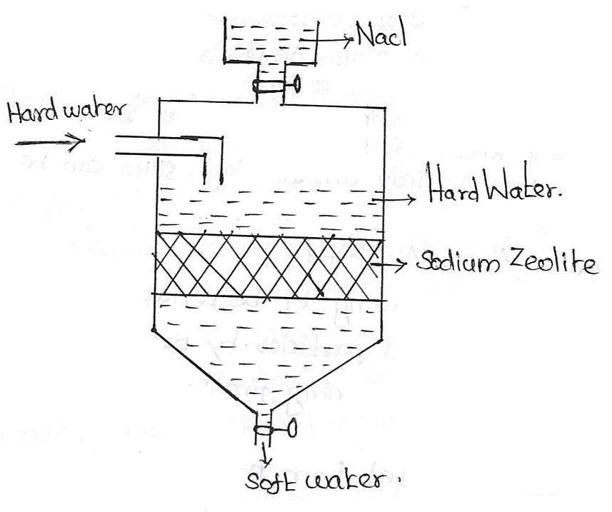
Na₂O.Al₂O₃.xSiO₂YH₂O.

The synthetic form of zeolite is known as PERMUTIT, which is porous and possess gel structure and Ze stands for insoluble zeolite.

Principle:The sodium ions which are loosely heldin Na₂Ze are replaced by Ca²⁺ and Mg²⁺ ions present in water.

Process: When hard water is passed through a bed of zeolite placed in a closed cylinder, the hardness causing ions like Ca²⁺ and Mg²⁺ ions are taken up by zeolite. Sodium salts are released during the reaction as byproduct.

For softening of water by zeolite process, hard water is percolated at a specified rate through a bed of zeolite, kept in a cylinder.

The hardness causing ions like Ca²⁺ and Mg²⁺are retained by the zeolite as CaZe and MgZe. While the outgoing water contains sodium salts.

The various reactions taking place may be
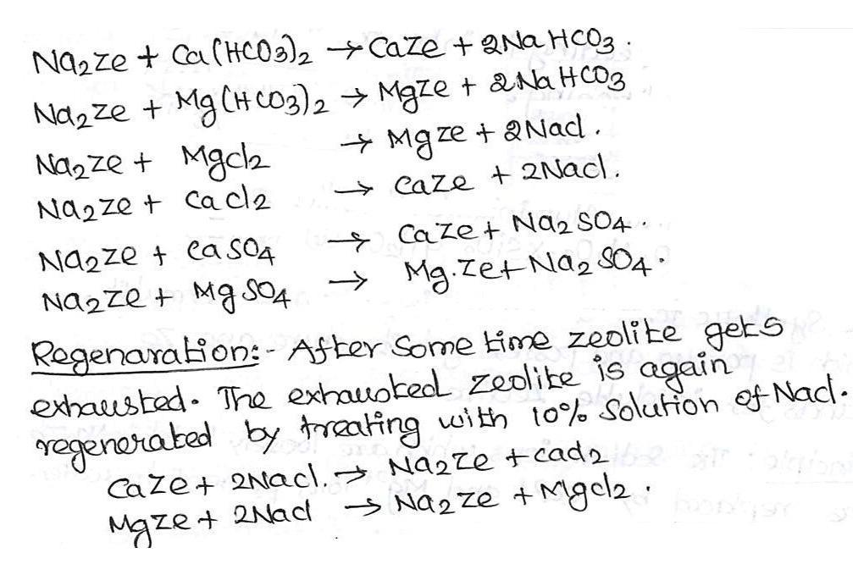

Advantages: (i). Output water has only 1-2 ppm. (ii). Operation is easy.

(iii). No sludge is formed during the process.

03. Explain formation of deposits in steam boilers and heat exchangers.

Steamboilers: Sealed vessel where water is converted to steam.

A steam boiler is a type of generator that is used to create steam.

Heat exchangers:A device for transferring heat from one medium to another.

Heat exchangers are designed to remove excess heat from aircraft engines, optics, x-ray tubes, lasers, power supplies, military equipment, and many other types of equipment that require cooling beyond what air-cooled heat sinks can provide.

Formation of deposits: Scale and sludge formation.

Scale:If the precipitate forms hard and adherent coating on the inner walls of the boiler is known asscale. It is formed by the substances like CaSO₄, Mg(OH)₂ and Ca(HCO₃)₂.

Scales are difficult to remove even with the help of hammer and chisel. Scales are the main sources of boiler troubles.

Formation of scales may be due to

(i). Decomposition of calcium bicarbonate.
(ii). Deposition of calcium sulphate.

(iii). Hydrolysis of magnesium salts.
(iv). Presence of silica.

Sludge:In boiler, water contains the precipitate loose and slimy is known as sludge. Itis formed by the substances like CaCl₂, MgCl₂, MgSO₄ and MgCO₃.

Disadvantages:

(i). Poor conductor of heat.

(ii). Excessive sludge formation disturbs the working of the boiler.

(iii). It forms along with scales, then former gets entrapped in the latter and both get deposited scales.

Prevention of sludge formation:

(i). By using well softened water.

(ii). By frequently below down opearation.

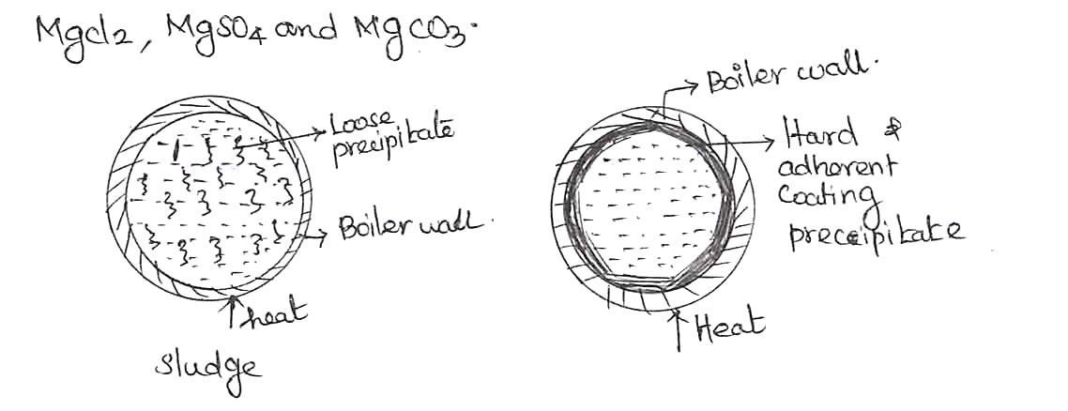

.

04. What are the disadvantages in scale formation? Explain in detail. Or

What are the disadvantages formation of deposits in steam boilers and heat
exchangers? Or

Write short notes on (i). Wastage of fuels. (ii). Decrease in efficiency. (iii). Boiler Explosion.

Disadvantages: (i). Wastage of fuels.

(ii). Decrease in efficiency.

(iii). Boiler Explosion.

(i). Wastage of fuels:
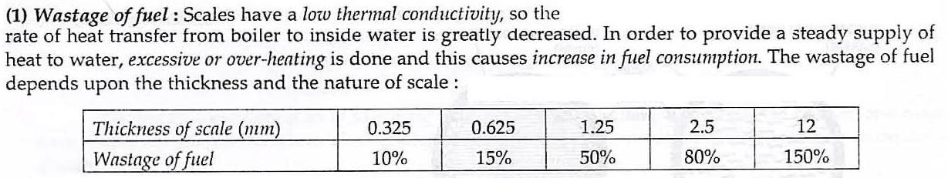

(ii). Decrease in efficiency:

Scales may sometimes deposit in the valves and condensers of the boiler and choke then partially. This results in decrease in efficiency of the boiler.

(iii). Boiler Explosion:

When thick scales crack due to uneven expansion, the water comes suddenly in contact with over-heated iron plates. This causes in formation of a large amount of steam suddenly. So sudden high-pressure is developed, which may even cause explosion of the boiler.

05. What are the disadvantages using hard water in boilers?

Disadvantages:

1. | Scale and sludge formation. | [seeQ.No: 3]
2. | Priming and Foaming. | [seeQ.No: 10]
3. | Caustic Embrittlement. | [seeQ.No: 7]
4. | Boiler Corrosion. | [seeQ.No: 9]

06. Explain prevention of scales formation.

Prevention of scales formation:
(i). External Treatment.
(ii). Internal Treatment.

(i). External Treatment:Softening of water (i.e) removing hardness- producing constituents of water. Ex: Zeolite process and Demineralization process.

(ii). Internal Treatment:Sequestration process.

An ion is prohibited to exhibit its original character by complexing or converting it into other more soluble salt by adding suitable reagent.

An internal treatment – by adding proper chemical to the boiler water either

(a). To precipitate the scale forming impurities in the form of sludge, which can be remove by blow–down operation (or)

(b). To convert them into compounds, which will stay in dissolved form in water and thus do not cause any harm.

Blow down operation: It is partial removal of hard water through top at the bottom of boiler, when extent of hardness in the boiler becomes alarmingly high.

Internal treatments methods are, generally, followed by blow-down operation , so that accumulated sludge is removed.

,
(i). Colloidal Conditioning (ii). Phosphate Conditioning (iii). Carbonate Conditioning (iv). CalgonConditioning.
07. Write short notes on Caustic Embrittlement.

Caustic Embrittlement. = Intercrystalline cracking of boiler metal

It is a type of boiler corrosion, caused by using highly alkaline water in the boiler.

In boiler water, it contains a small amount of sodium Carbonate. In high pressure, it decomposes to give sodium hydroxide.

Na ₂ CO ₃ + H ₂ O --- → 2NaOH +CO₂

Then this NaOH reacts with boiler material and it forms sodium Ferrate and this leads to brittlement of boiler parts like joints, bends etc.,

Fe+2NaOH --- → Na ₂ FeO₂ +H₂↑

It is prevented by or Avoided by

(i). By using sodium phosphate as softening reagent instead of sodium carbonate. (ii). By adding Tannin or Lignin to boiler water for blocks hair-cracks.

(iii). By adding sodium sulphate to boiler water also blocks hair-cracks.

08. Explain Internal conditioning methods of softening hard water.

To remove hardness producing salts, chemicals were added to the boiler water in the boiler itself and that treatment is called internal conditioning.

(i). Colloidal Conditioning (ii). Phosphate Conditioning (iii). Carbonate Conditioning (iv). Calgon Conditioning.

(i) Colloidal Conditioning:

In low-pressure boilers, scale formation can be avoided by adding organic substances like kerosene ,tannin, agar-agar (a gel), etc., which get coated over the scale forming precipitates, thereby yielding non-sticky and loose deposits, which can easily be removed by pre-determined blow-down operations.

(ii). Phosphate conditioning:

Three types of phosphates- mono, di and trisodium phosphates are employed in phosphate conditioning. The advantages of phosphate conditioning over carborateconditioning are (i).It can be applied to high pressure boilers and

(ii) It can be used for softening/ conditioning acidic, neutral or alkaline water sample.

Ca ²⁺ +2Na ₃ PO₄ --- →Ca ₃ (PO₄ )₂

If acidic water is to be conditioned, trisodium phosphate can be used. For neutral and alkaline water samples disodium phosphate and monosodium phosphate can be used respectively.

(iii) Carbonate conditioning:

In low pressure boilers, calcium ions are converted into soft and loose sludge by adding sodium carbonate solution. It forms soft CaCO₃ which can be removed by blow-down operation.

CaSO₄ +Na ₂ CO₃ --- →CaCO₃+ Na ₂ SO₄

(iv). Calgon conditioning:

Calgon interacts with calcium ions forming a highly soluble complex and it prevents the precipitation of scale forming salt. The complex Na₂[Na₄(PO₃)₆] is soluble in water and no problem for its sludge disposal.

2CaSO₄ + Na₂[Na₄(PO₃)₆] Na₂[Ca₂(PO₃)₆] +2Na₂SO₄

v) Sodium Aluminate Conditioning

- Sodium Aluminate reacts with boiler water to give NaOH and gelatinous precipitate of coagulant Aluminium hydroxide.

NaAlO₂+2H₂O NaOH+ Al(OH)₃

- Sodium hydroxide reacts with Mg²⁺ ions to give Magnesium hydroxide,

MgCl₂ + 2NaOH NaCl + Mg(OH)₂

- Finally it forms sludge which can be removed by blow down operation.

09.Write short notes on Boiler corrosion / Explain boiler Corrosion in detail / Write short notes on Boiler troubles – Boiler corrosion.

Boiler corrosion taken place in boiler in the presence of gases like dissolved oxygen, dissolved CO₂ and dissolved salts.

Dissolved oxygen:It attacks the boiler material at high temperature and causes theCorrosion.

4Fe+6H ₂O+3O₂ --- → 4Fe(OH)₃↓

It is removed by chemical and mechanical method.

Chemical Method: Sodium sulphite, Hydrazine used to remove dissolved oxygen. Mechanical Method: To remove by De-aeration method.

Water spraying in a perforated plate-fitted tower, heated from sides and connected to vaccum pump. High temperature, low pressure and large exposed surface reduces the dissolved oxygen in water.
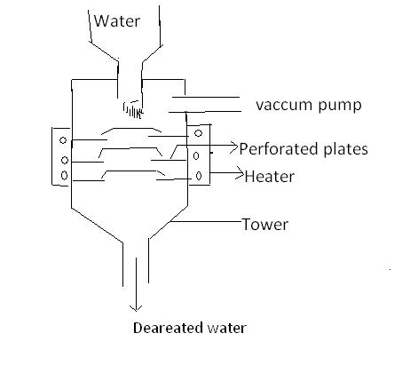

Dissolved CO₂: It produces carbonic acid, which is acidic and corrosive in nature

CO ₂ +H ₂ O --- → H ₂ CO ₃ ( Carbonic acid )

It can be removed by adding calculated amount of NH₄OH into water and also removed by de-aeration method.

Dissolved salts(MgCl₂):Salts like CaCl₂and MgCl₂undergoes hydrolysis at highertemperature , to give HCl , which corrodes the boiler

MgCl ₂ + 2H ₂ O --- → Mg(OH) ₂↓ +2HCl

Fe +2HCl --- → FeCl ₂ + H₂↑

FeCl ₂ + 2H ₂ O ---- →Fe(OH) ₂ +2HCl

It can be avoided by adding alkali into the boiler water.

10. Explain priming and foaming (carry over).

1.Priming: It is the process of production of wet steam.

Wet steam – Steam contains droplets of liquid water It is caused by

- High steam velocity

- Very high level water in the boiler

- Sudden boiling of water

iv).Very poor boiler design.

Prevention: It is controlled by

- Controlling the velocity of steam

- Keeping the water level lower

- Good boiler design

- Using treated water

2) Foaming:

The formation of stable bubbles above the surface of water is called foaming These bubbles are carried over by steam leading to excessive priming.

It is caused by

- Presence of oil and grease

- Presence of finely divided particles.

It can be prevented by

i). Adding coagulants like sodium aluminate

ii).Adding anti-foaming agents like synthetic polyamides.

11. What is Desalination? Describe desalination of by Reverse Osmosis method with neat diagram.

Or

Explain the reverse osmosis process for desalination of brackish water in detail.

Desalination = Removal of common salt-NaCl from water.

Brackish water = Water containing dissolved salts with a peculiar salty taste. Ex: sea water

Reverse Osmosis(RO):

When a pressure greater than osmotic pressure applied on the concentrated side, the solvent flow takes place from higher concentration to lower concentration is known as reverse osmosis.
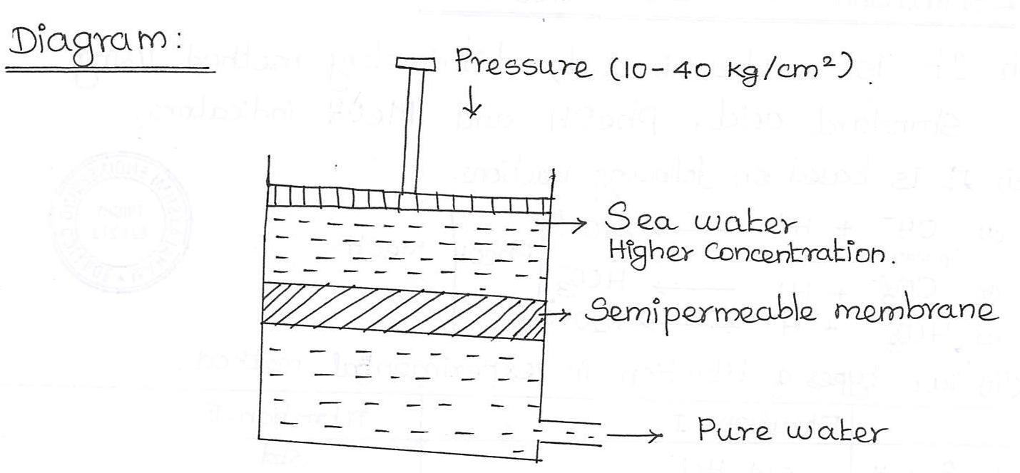

Process:

- In this RO process, Pure water is separated from salt water.

- This RO process is also known as Super filtration or Hyper filtration

- When the pressure is applied from the higher concentration side, the solvent flow takes place to lower side and these two concentrations are separated by semipermeable membrane, the salt water is converted into pure water.

- The membranes used as cellulose acetate, polyamide and some polymers.

Advantages & RO method:

- Low capital cost, easy operating.

- It is used for converting sea water into drinking water

- It removes all types of impurities like non-ionic and colloidal

- The life time of membrane is high and it can be replaced within few minutes.

12. Explain demineralization process in detail.
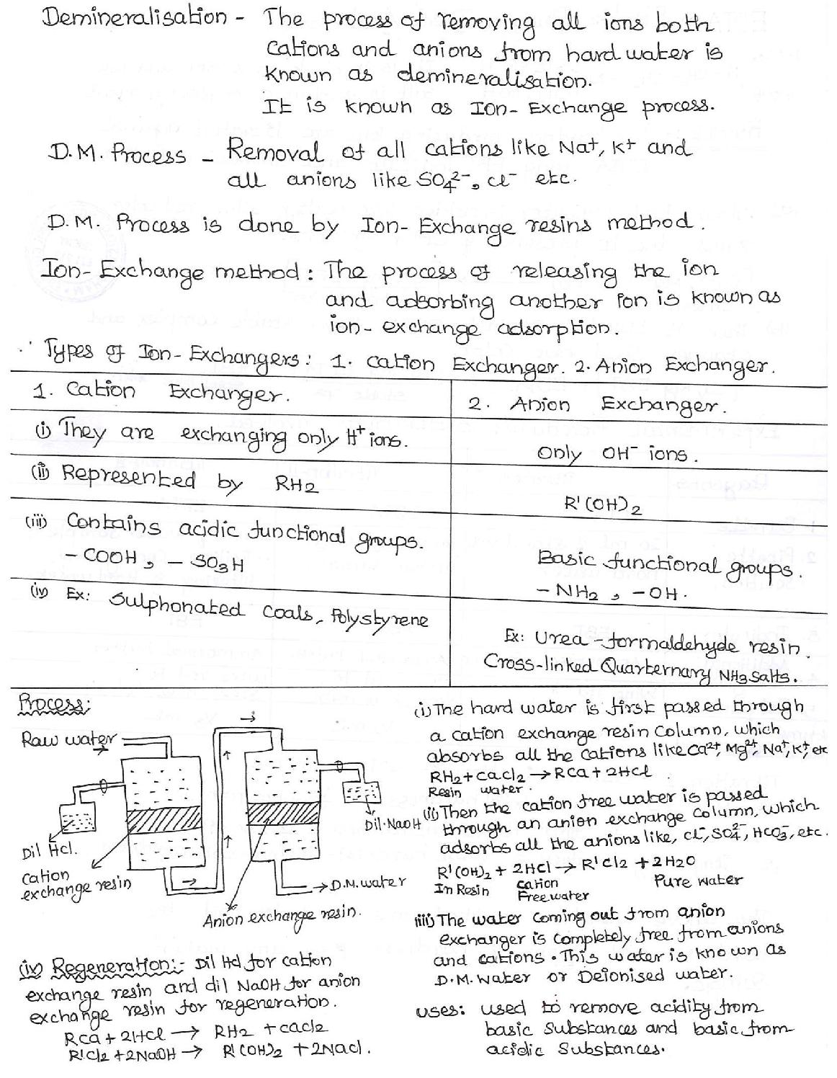

13. Explain Softening or Conditioning process.

Hard water is converted into soft water is called Conditioning or Softening Process.
Types of Process
1.External Conditioning Process
2.Internal Conditioning Process

External Conditioning Process
- It is carried out before its entry into the boiler.
- It is preventive method
- High Pressure boilers need this method.
- It includes lime soda Process,Zeolite (Permutit) process and Ion exchange Process

Internal Conditioning Process
- It is carried out inside the boiler itself
- It is a corrective method.
- Low pressure boilers requires this treatment
- It includes Carbonate conditioning, Colloidal, Phosphate, Calgon and Sodium aluminate.

14. Write the differences between Zeolite and demineralization Process.

Zeolite | Demineralisation
It exchanges only cations | It exchanges both cations and anions
It occupies less space | It occupies more space
Hardness range 0-15 ppm | Hardness rang 0-2 ppm

15. Define Potable water. Mention the standards of drinking water.
Water that is used for drinking purpose is called drinkable or Portable water.

Standards of drinking water
- It should be clear, colourless, odourless and tasteless.
- Free from suspended particles or colloidal impurities
- Free from microorganisms and bacteria
- Total dissolved solids should be less than 500 mg/l
- It should not have any toxic substances.

13. Discuss the various methods of disinfection . What is break point chlorination? State its significance.
The various methods of disinfection are
1.Boiling
2. Ozonation
3. Ultraviolet light
4.Chlorination
Water containing the following impurities bacterias, organic impurities,reducing substances, free ammonia.
Break Point Chlorination (Break Point Chlorination Curve ) : It may be defined as the chlorination of water to such an extent that not only living organism but also other organic impurities in water are destroyed.
When chlorine is added to water, it is used for different reactions like oxidation of oxidizable substance, chlorination of organic substance, destructive oxidation of organic substances and disinfection of pathogens.
Initially all the chlorine added is consumed and there is no free chlorine. This is due to complete oxidation of oxidizable substances. As the applied chlorine increases, there is steady increase in amount of residual chlorine. This stage corresponds to formation of chloro-organic compounds and chloramines when the dose of chlorine increase, destruction of chloro organic and chloramines take place.
Addition of chlorine in such dosages is known as break point or free residual chlorination. The breakpoint chlorination ensure complete destruction of organic compounds, which gives color, unpleasant odour and bad taste. In addition to it a complete destruction of disease producing micro-organisms is also ensured.

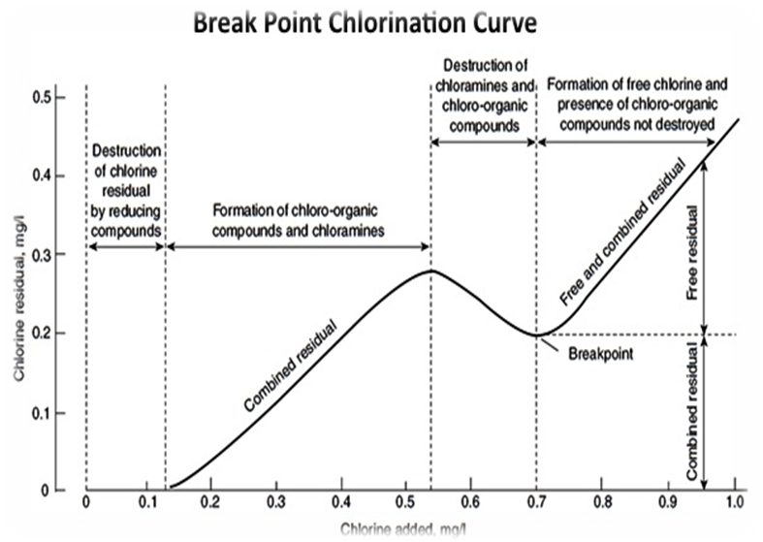

Advantages
(1) It oxidizes complete organic matters, dissolved ammonia and other reducing particles.
(2) It removes color (which is due to the presence of organic compounds).
(3) It destroys (~ 100%) all the bacterias.
(4) It removes bad odour and bad taste.

14. Discuss the domestic waste water treatment with neat diagram,

Raw water has to be treated safely to make it safe to drink. In water treatment various stages are present that can be indicated by following flow chart.

Source of water
Screening
Aeration
Sedimentation
Coagulation
Flocculation
Filteration
Disinfection
Storage

Screening :
By this process the floating materials like paper, plastics, twigs, leaves, logs, cloth, fish, plants and trash etc from the water are removed. The purpose of screening process is to avoid the entry of garbage into the water treatment plant and to prevent the clogging or damage of the pipe. The screening process has two filters
- Coarse filter
- Fine filter
Coarse filter is to remove the large floating garbage and twigs
Fine filter is to remove the smaller floating water plants leaves and so forth.
Thus the raw water is allowed to pass through both the filters to eliminate the floating particles.
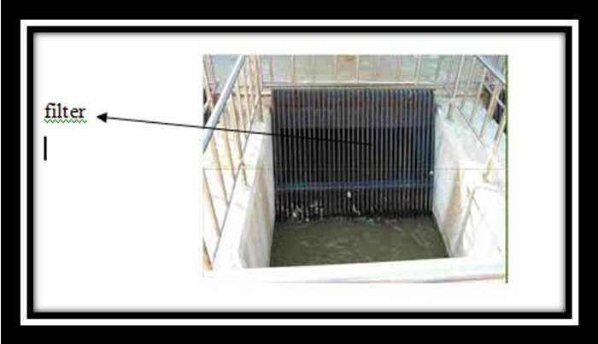

Sedimentation:
It is a process of removing the suspended impurities by allowing the water to stand undisturbed for 2-6 hr in a tank to settle the suspended materials due to the force of gravity.. Thus the suspended materials settled down and the suspended impurities are removed from the bottom. It removes 75% of the impurities.

Aeration:
After the sedimentation process the water is mixed with air which is called as aeration. This process is used to add oxygen for oxidation of undesirable substances like oils,algae, etc. It is mostly used for ground water not for surface water. It is also used to remove volatile liquids like phenols and humic acid. It increases the acidity of water. The process of aeration can be done by spray nozzle, cascade aerators, diffused air aerators and trickling bed air aerators.
Advantages :
Aeration processes promote the taste and odour of water.
It removes CO₂, H₂S and some volatile impurities which cause bad taste and odour to the water.
It removes Fe and Mn salts as their precipitate
Coagulation:
Some impurities like finely divided clay, silica not removed by sedimentation. Such type of impurities are removed by coagulation.. In this method certain chemicals called as coagulants (alum, sodium aluminate, FeCl₃, FeSO₄ etc) are added. Rapid mixing uniformly disperses coagulant.
When the coagulant is added it reacts with water to form a gelatinous precipitate which entraps the impurities
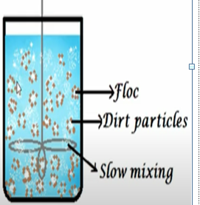

Flocculation
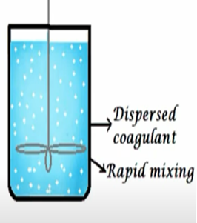
The slow mixing of coagulant will form a floc with dirt particles. The fine colloidal particles will combine with the impurities to form a bigger floc . The floc is heavier in size and settled down by sedimentation process.

Filtration:
It is the process of removal of colloidal and suspended matter, bacteria, odour, colour and taste etc. By passing the water through filter beds containing fine sand, coarse sand and charcoal/pebbles. When the water passes through the filter it removes the left out particles residual turbidity and few microorganisms. It also removes bad taste and odour.
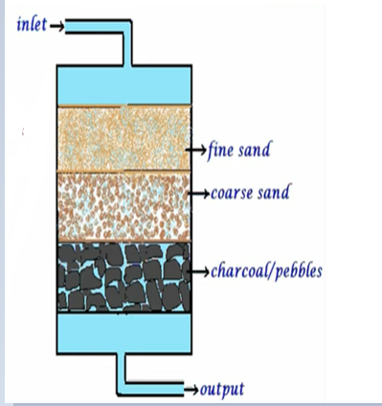
After continuous usage the rate of filtration decreases slowly due to the clogging of pores by impurities. Hence the top layer of the sand can be scrapped and replaced with new sand to avoid the decrease in efficiency

Disinfection:
The process by which harmful bacteria are destroyed to make the water safe for drinking is called disinfection. The chemicals or radiations used for this purpose are called disinfectants.
Disinfection methods includes
Physical methods- boiling, UV irradiations
And chemical methods- ozonation and chlorination.
Physical methods
1)Boiling:
When water is boiled for 10-15 min all the harmful bacteria’s are killed and water becomes safe for use
Disadvantages
1.The water taste is changed.
2.It is impossible for large treatment plants.
2) Ultraviolet light
UV rays are produced by passing electric current through mercury vapour lamp.
Electric current
Mercury vapour lamp
UV rays
This treatment is used particularly in Swimming pools. UV light alters the DNA of the bacterial cells that are exposed.
Merits:
(i) The disinfection is highly effective compared to chlorination and ozonation.
(ii) Disinfection by this process is a "clean" process, since no chemical additives
are used.
Demerits
(i) The unit is costly.
(ii) The method is not applicable to turbid water.

Chemical methods
3) Ozonation:
Ozone (O₃) is a powerful disinfectant and is readily adsorbed by water . As a powerful oxidant, it reduces the contents of iron, manganese, and lead, and eliminates most of the objectionable taste and odor present in water. Since ozone is relatively unstable, it is generated almost invariably at the point of use.
Ozone is highly unstable and readily decomposes to give nascent oxygen. This nascent oxygen is a powerful oxidizing agent and kills the germs in water.
O₃→ O₂ + [O] (Nasent Oxygen)
[O] + Bacteria → oxidized matter
Merits:
(i)Ozone removes color, odor and taste of water.
(ii) It does not leave any residue.
Demerits:
(i) It is not economical.
(ii) At high doses, ozone imparts a fishy odor to water.
(iii) It is unstable cannot be stored for long time.

4) Chlorination:
The process of adding Chlorine to water is known as chlorination.
Chlorination can be done by the following methods.
- By adding Chlorine gas
Chlorine gas can be bubbled in to the water
Cl₂+H₂O HCl + HOCl
- Bleaching powder. As a substitute for chlorine gas, bleaching powder can be used as disinfectant. Bleaching powder is nothing but calcium hypochlorite powder with the formula CaOCl_{2.}When bleaching powder is added to water, it dissoves in water and liberates the chlorine gas. This chlorine gas which in turn dissolves in water to form hypochlorous acid (HOCl) is produced. HOCl is a powerful disinfectant.
CaOCl₂ + H₂O 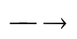 Ca(OH)₂ + Cl₂
Cl₂ + H₂O HCl + HOCl (hypochlorous acid)
HOCl + Bacteria 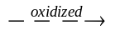 Organic matter
Merits:
(i) It is economical.
(ii) It can be applied even for small communities and small water supply schemes.
Demerits:
(i) It is highly unstable and hygroscopic. When exposed to air or moisture, it
looses its strength. Hence it should be stored only in tight containers.
(ii)The disinfection effect is effective for certain period of time (about 30 minutes) only.

- Chloramines: Chlorine is unstable in water. Hence, it is mixed with ammonia to form chloramine. This chloramine which in turn dissolves in water to form hypochlorous acid (HOCl) is produced. HOCl is a powerful disinfectant.
NH₃ + Cl₂→ NH₂Cl + HCl(formation of monochloramine)
NH₂Cl + H₂O→ NH₃ + HOCl (hypochlorous acid)
Merits:
(i) Chloramines impart good taste and do not give irritating odor.
(ii) Chloramines help to maintain the disinfection effect up to the consumer end.
Demerit:
- May be carcinogenic.
- Break point chlorination : refer answer 13

15. Discuss the water quality parameters in detail.

1. Color:
- Pure water is colorless. Therefore any types of color appearance in water indicates water pollution.
- Natural water system is often colored by foreign material. If color is due to suspended material, it is called as apparent color. Color given by dissolved material that remains even after removal of suspended material is called true color or real color.
- The guideline value (maximum acceptable level) for color of drinking water is 15 TCU (True color unit).

2. Taste and odor:
- Pure water is always tasteless and odorless. Therefore if any types of taste and odor is present, it indicates water pollution.
- Water taste and odor may develops due to natural or artificial regions.
- Artificial region for taste and odor in water is due to disinfection process (chlorination). Some natural impurities dissolved in water can also give taste and odor.
- Inorganic salts such as NaCl, KCletc dissolve in water give taste whereas compounds like H2S can give both taste and odor.
- Compounds giving taste and odor to water may be toxic to consumer, so drinking water should be taste less and odor less.

3. Turbidity:
- Pure water is clear and do not absorb light. Therefore if turbidity appears in water, it indicates water pollution.
- Turbidity in water is given by various materials like suspended solid, dissolved materials and microbial loads. In general turbidity increases with increases in quantity of these materials in water. However different materials differ in their light absorption capacity.
- Some materials that give turbidity may be toxic to consumers. Therefore turbid water is not suitable for drinking purposes. Furthermore turbidity decrease efficiency of disinfection process.
- Materials that give turbidity provide attachment site for toxic chemicals.
- Turbidity prevents penetration of light into deeper layer of natural water system that directly affects photosynthetic organism in bottom.
- Drinking water should have turbidity less than 5 NTU (Naphthalometric turbidity unit)

4. pH:
- Water become alkaline due to presence of Nh3, OH-, Ca++, Mg++ etc. in alkaline water certain minerals are deficient. Alkaline pH also decreases efficiency of disinfection process (chlorination).
- Water become acidic due to presence of dissolved acids and dissolved carbon-dioxide. Acidic pH corrodes pipeline. Similarly certain minerals are more than excess in acidic water.
- pH of drinking water should be around 6.5-8.5

5. HARDNESS
Hardness is the property of water which is indicated by the failure to lather with soap. When Ca or Mg is present in water, the alkali salt of fatty acid (like stearic acid) in soap precipitates as Ca/Mg-Stearate and therefore no lather is formed.
2 C₁₇H₃₅COONa + CaCl₂ (C₁₇H₃₅COO)₂Ca ↓ + 2 NaCl.
Ca-stearate

The hardness producing ions viz. Ca and Mg in water, give wine red color with Eriochrome Black-T indicator.

Types of hardness
Hardness of water can be classified into two types:
Types of Hardness
Temporary (or)
Carbonate hardnesss
Permanent (or)
Non-carbonate hardness
a) Temporary hardness or Carbonate hardness: This is due to the presence of bicarbonates of calcium and magnesium. Temporary hardness can be removed (i) by boiling or (ii) by adding lime to the water. The above two processes convert the bicarbonates into insoluble carbonates and hydroxides, which can be removed by filtration.
Ca(HCO₃)₂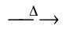 CaCO₃↓ + H₂O + CO₂
Mg(HCO₃)₂ + 2 Ca(OH)₂ Mg(OH)₂↓ + 2 CaCO₃↓ + 2 H₂O.
(b) Permanent hardness or non-carbonate hardness: This is due to the presence of chlorides and sulphates of calcium and magnesium. It cannot be removed by boiling the water. But it can be removed by (i) lime-soda process or (ii) zeolite process.
CaCl₂ + Na₂CO₃ CaCO₃↓ + 2 NaCl
Soda

CaSO₄ + Na₂Ze CaZe + Na₂SO₄.
Sodium zeolite

Water is classified as on the basis of concentration of calcium carbonate
  - Soft water:<5omg/ltr
  - Moderately hard water: 50-150 mg/ltr
  - Hard water: 150-300 mg/ltr
  - Very hard water:>300 mg/dl
Hard water is not suitable for industrial use. But hard water is usually beneficial for drinking purposes. However hardness caused by MgSO4 give some serious health effects. So, concentration of Mg++ should not exceeds 50 mg/lt in drinking water.
Units of hardness
Hardness can be expressed in different Units:

(i) ppm: parts per million expressed as CaCO₃
(ii) mg/L: milli gram per one liter of water expressed as CaCO₃

6. ALKALINITY
The ‘acid-neutralizing capacity’ of water is defined as alkalinity of water. It is a measure of the aggregate property of water in terms of treatable bases like bicarbonate, carbonate and hydroxide.

Significance of alkalinity
Alkalinity is significant in many uses and treatments of natural waters and wastewaters. Alkalinity is one of the parameters that decide the suitability of water for irrigation.
For drinking water, the maximum allowable guideline value for alkalinity is 600 mg/L expressed as ‘CaCO₃’. Taste of high alkaline water will be unpleasant. Rice boiled with high alkalinity water will be yellow in color. High alkaline water may also cause some digestion problems.

Types of alkalinity
The most common substances that contribute for alkalinity in natural water are bicarbonate [HCO₃⁻], carbonate [CO₃²⁻] and hydroxide [OH⁻]. The measured value of alkalinity varies significantly with the end-point pH used. Of the three types of alkalinities mentioned above, only bicarbonate alkalinity will be present in water when the pH is below 8.3.
If present, borates, phosphates, silicates and other bases can also contribute for alkalinity.

7. Total dissolved solid:
- If water is filtered to remove suspended solid, the remaining solid in water indicates total dissolved solid.
- Dissolved solid may be organic (animal or plants waste) or inorganic compounds (carbonate, sulfate, bicarbonate etc). These compounds give variety of effects like hardness, taste, odor etc depending on nature of dissolved solid.
- If the dissolved solid in water exceeds 300 mg/ltr, it adversely affects living organisms as well as industrial products.

8. Chemical oxygen demand (COD):
- COD is amount of oxygen needed for oxidation of organic matter present in water by strong chemical oxidizing agents such as K2Cr2O7.
- COD measurement is particularly valuable to determine amount of organic matter in water which contains toxic or antimicrobial chemicals.
- K2Cr2O7 is strong oxidizing agents and it oxidizes both biodegradable and non-biodegradable organic matters. Therefore the value of COD is always greater than BOD for particular water sample.
- COD gives amount of total organic (biodegradable + non-biodegradable) matter present in water.

9. Biological oxygen demand (BOD):
- Biological oxygen demand represents amount of oxygen required by living organism (microorganism) for oxidation of biodegradable organic matters present in water under aerobic condition.
- BOD is a direct measurement of quality of oxygen needed for biodegradation of organic matter and indirect measurement of quantity of biodegradable organic matter in water.
- When biodegradable organic matter is added in water. Microorganism utilizes dissolved oxygen to oxidize organic matter. If the rate of consumption of oxygen during biodegradation is greater than solubilization of atmospheric Oxygen into water, level of dissolved oxygen gradually decreases.
- If organic matter content is very high, complete loss of dissolved oxygen occurs. This creates anaerobic environment in water. In this case aerobic aquatic organism cannot survive.
- Furthermore, if dissolved oxygen is absent then organic matter starts to decompose anaerobically that creates taste and odor problem.
- High value of BOD is an indicator of water pollution.

